Guided Exploration M02: Inheritance Polymorphism and Big O Analysis
Points: 25 (See Rubric in Canvas)
Due Date: Due date listed in Canvas
- Final submission will be accepted up to 24 hours after the due date with a 10% penalty. Meaning if you turn it in at 12:01 am of the next day you will be deducted 10% of the total points from your score.
- If the assignment is more than 24 hours late, it will be a 0.
Submission: Upload files separately and do not upload a zip file. Only use concepts that have been covered in class lectures so far.
- Two Document Files as PDF or Word document:
  - GE02 Documents with your answers in the highlighted areas unless otherwise stated
  - Technical Document
- 1 Java File from 2.2 Inheritance and Polymorphism (. java files NOT CLASS FILES)

Objectives: See Module 2 Objectives in Canvas

Effort: You are encouraged to collaborate to discuss concepts and explore writing code together. Write your technical documentation and answer the questions in your own words. You can use AI tools but follow CS Academic Integrity and AI Usage Policy - Harding

If you download this as a word document and you have any problems typing your answer in the tables you must click on 3 dots and remove content control.
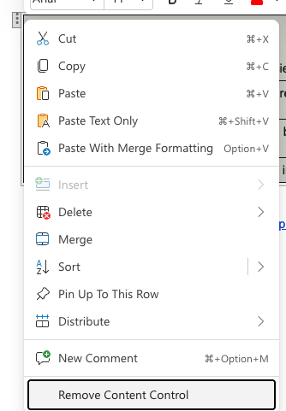

Part 1: Explore and Explain
Part 2: Analyze and Apply
2.1 Search Algorithms and Big-O Lab
2.2 Inheritance and Polymorphism (Do not start until introduced in lecture)
Learnings and Reflections

Part 1: Explore and Explain
Purpose: Professional communication to demonstrate your learnings by connecting different ideas from lectures or provided resources.

DOs
- Use clear headings, table of contents, and consistent formatting.
  - Headings, Subheadings, and Table of Contents (Google Docs)
  - Headings, Subheadings, and Table of Contents (Microsoft Word)
- Use lists and tables to organize information
- Provide explanations in your own words — no copy/paste from slides.
- Include code examples that you explored and edited, screenshots, or diagrams.
- Include links to resources from the lecture or find your own external resources (websites, AI, videos) with a brief summary .

DON’Ts
- copy my explanations from the slides, AI, Websites, or others as your work
- Use AI to create your technical documentation.

Look at module 2 objectives for topics to include. Use some of the labs you did in class or below to help you summarize the concepts.

Part 2: Analyze and Apply

2.1 Search Algorithms and Big-O Lab
Purpose:
- Implement and test the linear and binary search algorithm.
- Analyze best, average, and worst cases.
- Connect lab results to Big-O complexity (O(n)).
Note: Binary search requires a sorted array. In the starter main, arrays are created in sorted order (1..n).

1. In your own words, what does Big-O notation describe?

Big-O notation describes how an algorithm’s memory/time usage grows with the input size

2. Why is it important to test an algorithm with different cases (best, average, worst) instead of just one case?

To make sure that the algorithm works in all/most scenarios, and not just for a single input
3. For linear search:
Best case input (array size and key location): Any array size, with the key location at index 0
Worst case input:
an array where the key is in the very last index, or not present in the array at all
A reasonable “average case” input:
An array where the key is found near the middle of the array

4. For binary search:

Best case input: an array that has the key in the exact middle index
Worst case input: An array where the key is near the end of the search range or not found in the array

How does not found behave relative to worst case?
Similar results, as both need to search the entire array to get the result

5. Which algorithm do you expect to scale better as arrays grow very large? Why?
Binary will scale better, because it cuts the search area in half with each step, whereas linear search checks every index until the key is found

- Use this code M02SearchAnalysis.java. Add comments to the code to show you understand what the code is doing. Linear search counts one comparison each time you check arr[i] == key.
- Make a copy or download the spreadsheet LinearSearchAlgorithmAnalysis.xlsx. Fill in the results from the output and the graph will be created for you to analyze. Put a screenshot of the results below.
Graph:
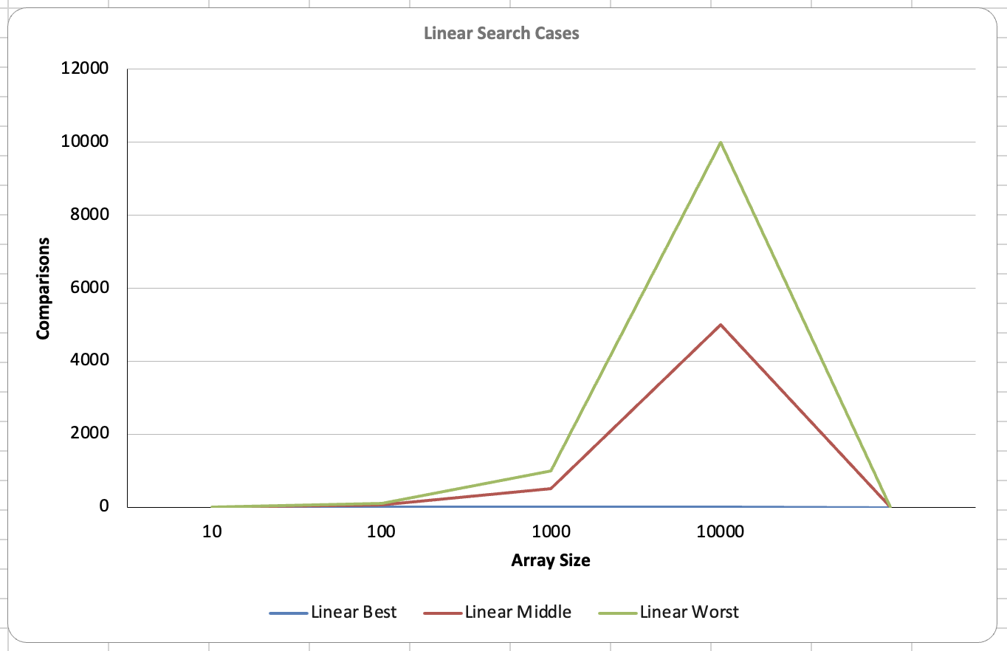

- Answer the following
1. How many comparisons are made in the best case?
1
2. How many comparisons in the worst case?
Equal to the size of the array
3. On average, how many comparisons are made?
Array size / 2
4. Why is linear search considered O(n)?

5. If you double the array size, what happens to the number of comparisons in the worst case?
Because the number of comparisons grows directly with the size of the array

- Add comments to the code to show you understand what the code is doing. Binary search: count two comparisons per loop iteration:
  - Each time through the loop, you always check “is arr[mid] == key?” → that’s 1 comparison.
  - If it’s not equal, you also check “is arr[mid] < key (or > key)?” → that’s 1 more comparison.
  - So in most iterations, binary search makes 2 comparisons.
- Make a copy or download the spreadsheet BinarySearchAlgorithmAnalysis.xlsx Fill in the results from the output and the graph will be created for you to analyze. Put a screenshot of the results below.
Graph:
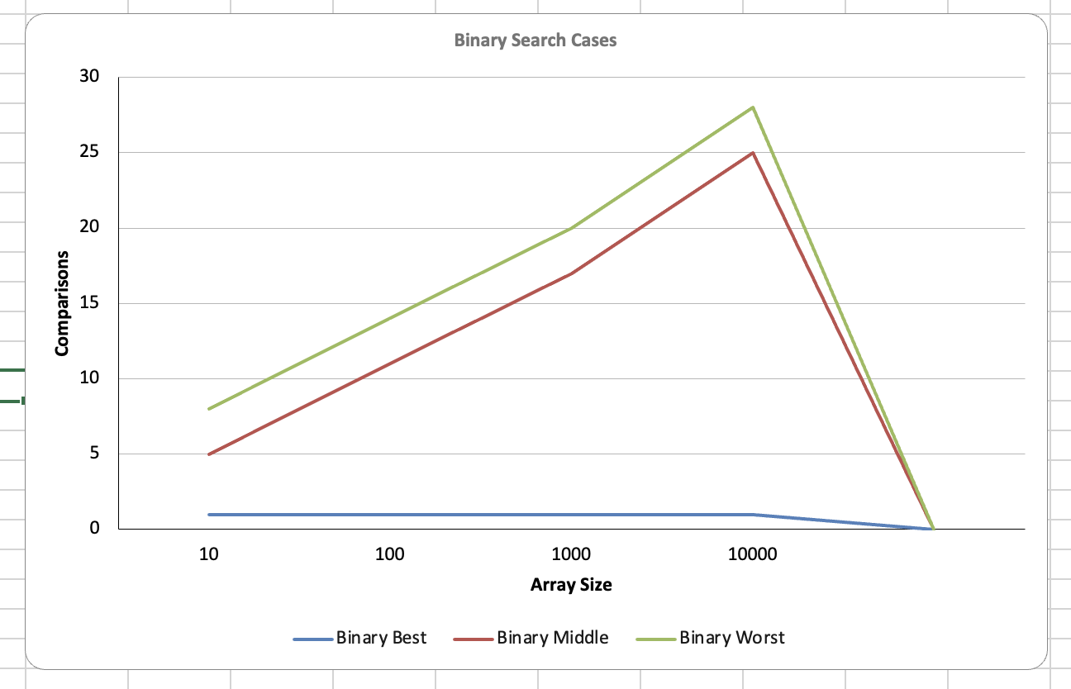

- Answer the following
1. How many comparisons are made in the best case?
1
2. How many comparisons in the worst case?
About log^2(n)
3. On average, how many comparisons are made?
Just a little less than worst case, still ~ log^2(n)
4. What is the binary search considered in Big O
O(log n)
5. If you double the array size, what happens to the number of comparisons in the worst case?
Increases by ~1 comparison every time you double the array size
- Comparing linear to binary search?

1. How does the number of comparisons for binary search compare to linear search in best, average, and worst cases?
In best case, both can find the key in 1 comparison; However, for average and worst, Binary uses far less comparisons since it cuts the search area in half with each step, and linear checks each index

2. If you double the array size, how does the number of comparisons in binary search change compared to linear search?
For binary, the number of comparisons would increase by 1, whereas linear would increase by about double
3. For small arrays (like 10–20 elements), do you notice much difference between the two searches? What about larger arrays (e.g., 1,000 elements)?
Both searches finish pretty quick in small search samples, but for larger arrays, binary is much faster than linear search in almost all cases

2.2 Inheritance and Polymorphism (Do not start until introduced in lecture)
Update the library app to support print and e books so
- Abstract book class
- PrintBook and EBook extends Book
Class Design

<<abstract>> Book
- title: String
- author: String
- year: int
+ Book(String:title, String:author, int:year)
+ getTitle(): String
+ getAuthor(): String
+ getYear(): int
+ toString(): String instead of stringOfBookDetails();
+ calculateLateFee(daysLate:int) : double {final}
+ getLoanDays() : int {abstract}
+ getDailyLateFee() : double {abstract}

PrintBook extends Book | EBook extends Book
+ Book(String:title, String:author, int:year)  + toString(): String  + getLoanDays() : int (just return hardcoded 21)  + getDailyLateFee() : double (just return hardcoded .25) | + Book(String:title, String:author, int:year)  + toString(): String  + getLoanDays() : int (just return hardcoded 14)  + getDailyLateFee() : double (just return hardcoded .10)

Here is code for calculating the late fee

// Shared behavior using polymorphism
/** Calculates the late fee based on subclass policy. */
public final double calculateLateFee(int daysLate){
double lateFee = 0;
if (daysLate > 0){
lateFee = daysLate * getDailyLateFee();
}
return lateFee;
}

Unit test the new PrintBook and Ebook class with the changes.
When printing out the book information it should print “Title” by Author (year) [Book type, days, charge/day]
"Unmasking AI" by Joy Buolamwini (2023) [Print, 21 days, $0.25/day]

Upload your library app Java code with your submission.

Learnings and Reflections

1. In the UML diagram, which methods are marked abstract and which are already written (concrete)? Why do we make the Book class abstract?

getLoanDays and getDailyLateFee are abstract, the rest are concrete.

The book class is abstract because we want to always specify what type of book we are constructing(Ebook or PrintBook), and do not want to construct plain Book objects
2. What actions (behaviors) are different for PrintBook and EBook?
The abstract methods, getLateFee and getLoanDays, return different values

What are the same?
The concrete methods defined in the Book class
3. Why is the method calculateLateFee(int) written once in Book instead of repeating it in both PrintBook and EBook? Why is this method final?
Because the arithmetic can be used for multiple types of book, we follow DRY by defining the code once, and then changing the variables(late fee, days loaned) depending on the actual object. The method is final so that subclasses cannot change the logic by overriding the method

4. Write the PrintBook and EBook constructors calling super(...). What happens if you forget super(...)?
If you do not call the super-constructor, java will attempt to call the no-args super constructor ( super() ); since this doesn’t exist because we made our own constructor, but did not create a no-args constructor, you will get a compile-time error informing you that you must use an implicit call to the super constructor.

5. When you go through the array of books on the shelf and call toString() what is running in what order in the 3 book classes?
The toString() method for the actual book type will run, not the super, as the method is overwritten in Ebook and PrintBook

6. Explain polymorphism using examples from your code.

Polymorphism means one reference type can refer to different object types, with java calling the correct overridden method for that specific object. In my code, the Book[][] can store both Ebook and PrintBook types, as they are both of the type Book. When overridden methods are called, Java will choose the correct version of the method based on the subclass that is calling it

7. In one sentence, explain what it means that Java chooses the correct version at run time.

Java looks at the object type and calls the correct method version once the program is running
8. Where do you see separation of responsibilities between Book and its subclasses?
Book is responsible for handling all data and behavior shared by each book, with the subclasses handling details that vary by type, such as late fee and loan days.

9. What are you most proud of from this module that you understand?
I am most proud that I still understand how inheritance and polymorphism work together. I can see how a superclass can hold shared fields and methods, while subclasses override only the parts that need to behave differently. I also understand why abstract classes are useful when I want to force subclasses to provide details for their own specific behavior.

10. What is the most complex concept you are still trying to understand?

I think Big-O notation and Dynamic binding are a little difficult to understand than the other concepts from this module

